Sprint Retrospective – 24.04

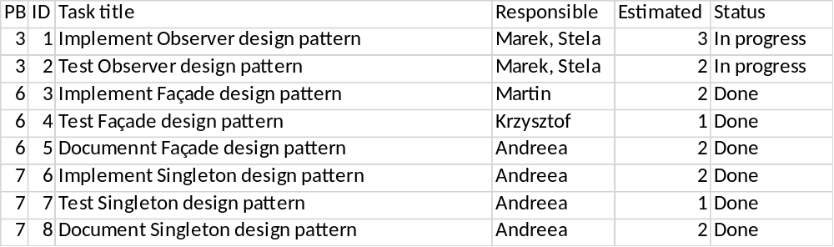

This sprint started Construction phase of UP.

Tasks for this sprint has been planned according to the chart. The observer design pattern implementation has started; however, no working result was made. Façade design pattern has been implemented and tested. Documentation of façade followed. Static class DataHandler was changed to singleton design pattern, which was fully implemented, tested and documented during the sprint.
During this sprint we have found out that we are in need of new product owner, since Martin didn’t have enough time courtesy of personal reasons. Team met before sprint review and we came to decision that the new product owner will be Andreea.

